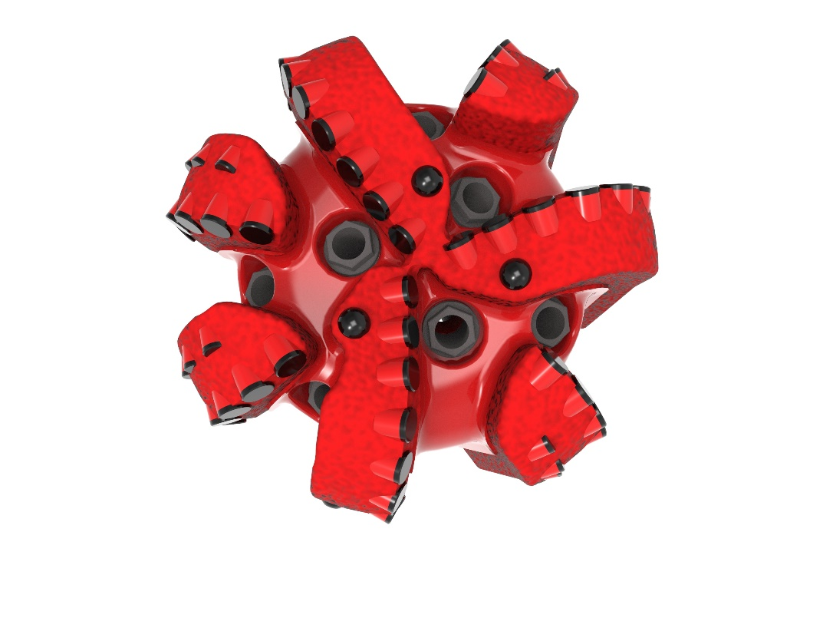
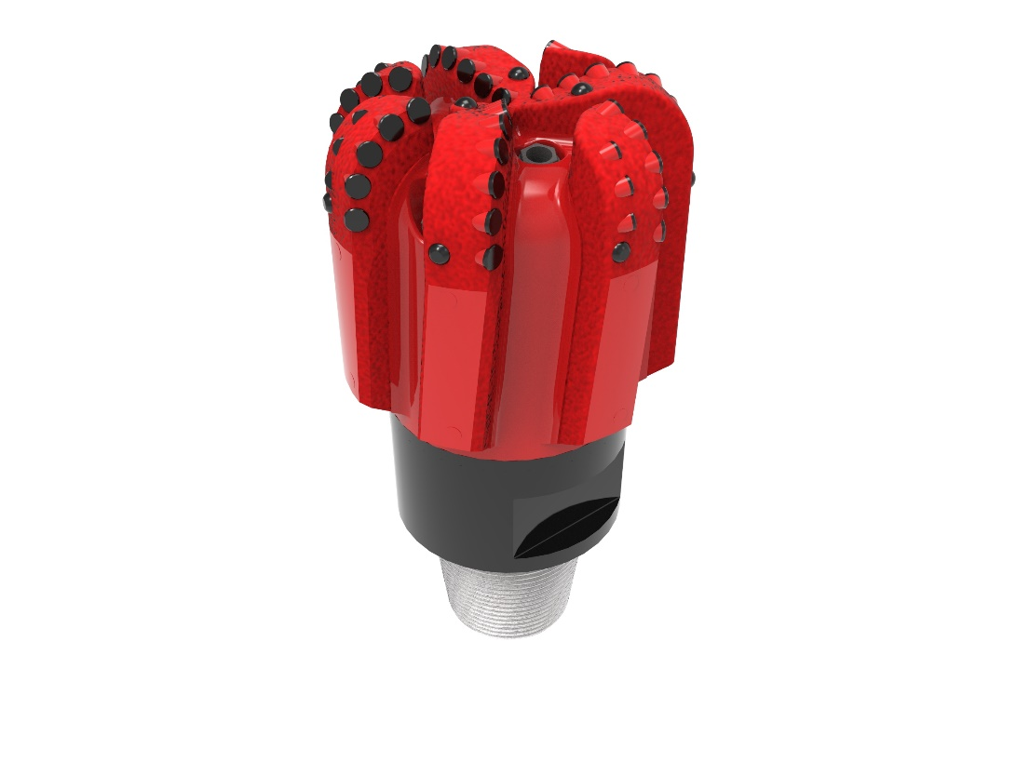

Drill Bit Specifications:
Cutter Size (Primary, Sec) | 1/2”, 7/16”
Cutter Count (Total, Gage) | 56, 7
Blade Count | 7
Gage Length (Inches) | 4.00
Nozzle Count (Primary, Sec.) | 7
Nozzle Series (Primary, Sec.) | 60
JSA (Sq. Inches) | 12.41
Max. TFA (Sq. Inches) | 2.60
Operating Parameters:
Max. Weight on Bit (1,000 Lbs.) | 60
Make-up Torque (ft/lbs) | 17,399
Nominal Dimensions:
Overall Length (Inches) | 15.99
Make Up Length (Inches) | 11.93
Bit Breaker | SKB-21010
Connection | Ø4-1/2" API Reg.
Approx. Weight (Lbs.) | 120

Standard Features:

- Premium grade cutters maximize ROP and Life
- Nozzle configuration and large open face volume optimize blade cleaning and cuttings removal

713-SR+(K) Nomenclature Explained:

• | 7 | = | Number of blades
• | 13 | = | Primary Cutter Size (13mm)
• | SR+ | = | Partial Backup Row of Cutters
• | K | = | Bullets


